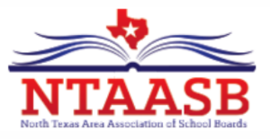
All School Boards in Regions 10 AND 11 are Invited to Join
The North Texas Area Association of School Boards
For the 2026-2027 School Year

About NTAASB
- Vision: To create a conduit for school board success.
- Mission: To strengthen communication, collaboration, and connection among all members.
- Purpose: To present programs that benefit members, cooperate with the state legislature in the enactment of laws to benefit public schools, offer continuing education credit for board members.
Why Should a District Join NTAASB?
- NTAASB meetings are excellent opportunities not only to experience a wide array of programs impacting
public education, but to network with fellow trustees in Regions 10 and 11.
- Trustees can earn Continue Education Credit (CEC) when attending meeting
with non-legislative advocacy topics.
- NTAASB offers four meetings each year, with dinner included.
What is the Cost to the District for Membership in NTAASB?
Student Enrollment | Yearly School District Dues
Less than 2,000 | $50
2,000-9,999 | $100
10,000 and above | $150

To become a member district of NTAASB, please fill out this form and mail to address listed.
School District______________________________________________ Invoice Date_________________
School District Address____________________________________________________________________
Payment Enclosed $ ________________________
Contact Person:
Name__________________________________________________ Phone_______________________________
Email_____________________________________________________
NTAASB TAX ID # 75-1545304
Mail to:
NTAASB Treasurer
ATTN: Robert Selders, Jr.
4410 Meadowcove Drive
Rowlett, TX 75088

